

**Polling District and Polling Place Review 2025**

**Heaton Ward**

**Parliamentary Constituency:** East and Wallsend

**(Proposed) Polling Districts:** L01, L02, L03, L04, L05, L06

The Local Government Boundary Commission for England are an independent body accountable to Parliament. They are responsible for reviewing councils to make sure their patterns of internal wards are fair and sensible. Their reviews include at least two rounds of public consultation before they make recommendations for change.

The final recommendations were published on 7 January 2025, and the new arrangements apply to local elections from 2026.

As a result of changes to ward boundaries the Acting Returning Officer (ARO) is conducting a review of polling districts and polling places to ensure that they are suitable for the new ward boundaries.

For more information on the local government boundary review visit: <https://www.lgbce.org.uk/all-reviews/newcastle-upon-tyne>

This document provides details of the review, along with the initial recommendations and comments of the Acting Returning Officer (ARO). Also, the election rules require the ARO to decide how many polling stations are required for each polling station and the ARO must allocate electors to the polling stations in such manner as they think most convenient.

These recommendations will be open to all residents, stakeholders, and any interested parties. We shall be seeking representations from local disability groups on the accessibility and suitability of polling places. Any comments should be addressed in the first instance to pollingplaces@newcastle.gov.uk where they will be collated on behalf of the (Acting) Returning Officer.

We considered the following factors:

* **Identifying new polling places:** We will look for new polling places in areas where the existing provision is unsuitable or unavailable.
* **Feedback:** We will consider feedback received following recent elections, consultation from members of the public, elected members, and other stakeholders.
* **Accessibility:** We will try to ensure that every polling place is accessible to electors with disabilities.
* **Facilities**: We will make sure that all electors have such reasonable facilities for voting as are practicable in the circumstances.
* **Elector numbers:** We will try to comply with the Electoral Commission guidance on the maximum number of electors that should be allocated to a polling station which should not exceed 2,250.
* **Future housing developments**: We will consider the impact of proposed housing developments on polling station electorates.

**(Current) Heaton Ward**

This map shows the current ward and polling district boundaries and the polling places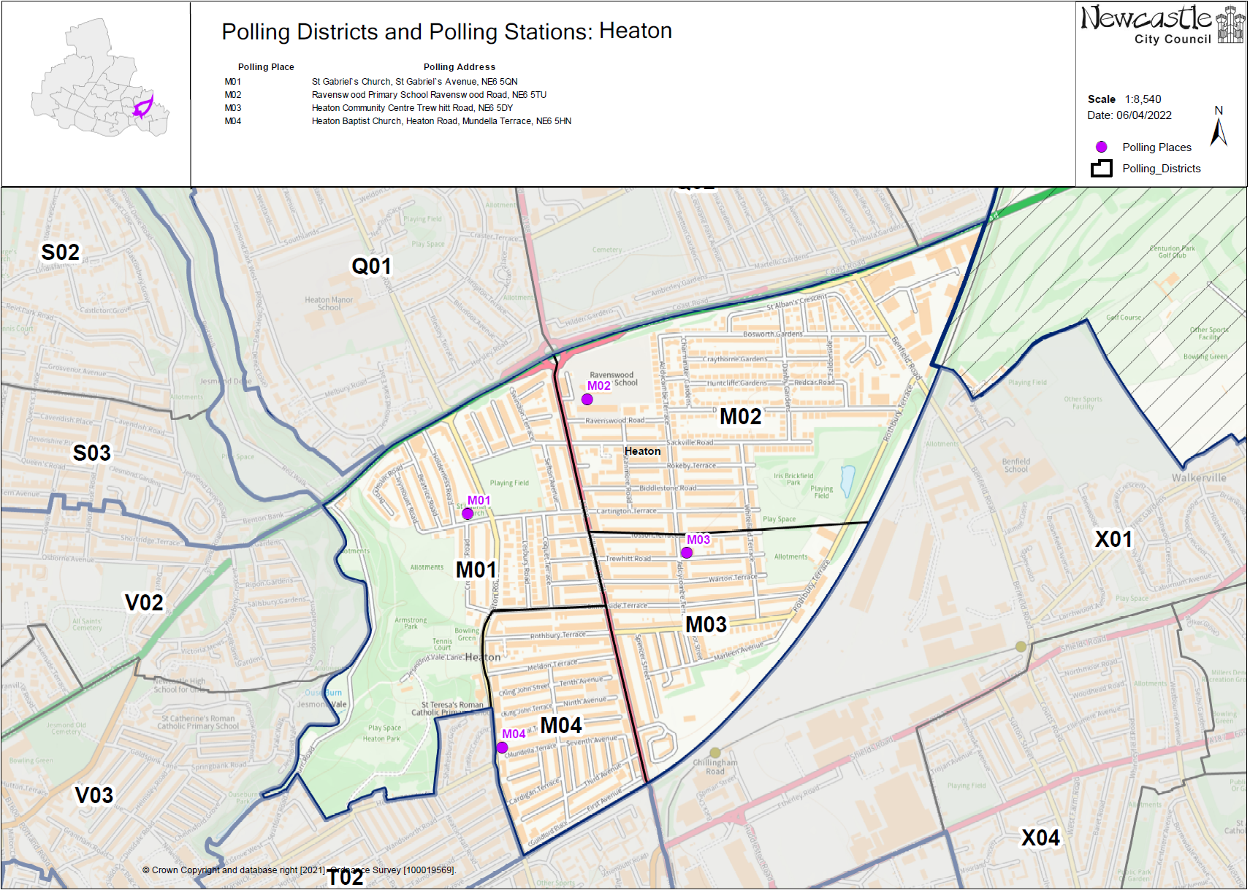.

**(New)**

**Heaton Ward**

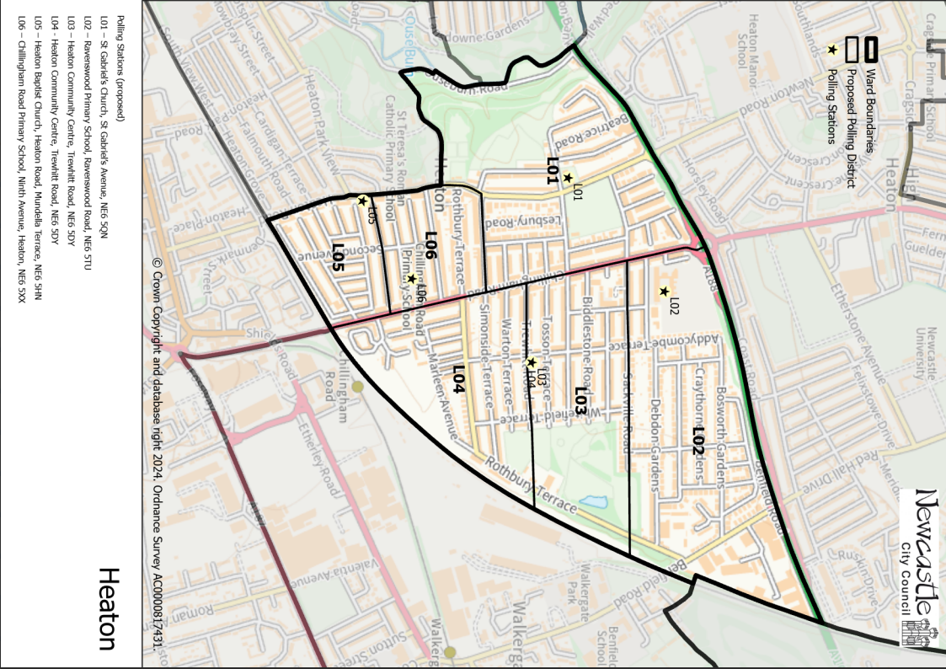

This map shows the new ward and the proposed polling districts and the proposed polling places.

* L01 – St Gabriel’s Church, St Gabriel’s Avenue, NE6 5QN
* L02 – Ravenswood Primary School, Ravenswood Road, NE6 5TU
* L03 – Heaton Community Centre, Trewhitt Road, NE6 5DY
* L04 – Heaton Community Centre, Trewhitt Road, NE6 5DY
* L05 – Heaton Baptist Church, Heaton Road, Mundella Terrace, NE6 5HN
* L06 – Chillingham Road Primary School, Ninth Avenue, Heaton, NE6 5XX

**Heaton Ward**

**Polling District L01**

|  |  |
| --- | --- |
| **Current Polling District** | **Current Polling Place** |
| M01 (part of) | St Gabriel’s Church, St Gabriel’s Avenue, NE6 5QN |

|  |  |  |
| --- | --- | --- |
| **Proposed Polling District** | **Predicted**  **Polling Station Electorate** | **Proposed Polling Place** |
| L01 | 1003 | St Gabriel’s Church, St Gabriel’s Avenue, NE6 5QN |

|  |
| --- |
| **Considerations and Proposals** |
| Part of current M01 would become the proposed L01. Loses part of the district south of Armstrong Park to Ouseburn ward.  No change to the polling place. |

|  |
| --- |
| **Preliminary Consultation – Elected Members comments and feedback** |
| No comments received. |

**Heaton Ward**

**Polling District L02**

|  |  |
| --- | --- |
| **Current Polling District** | **Current Polling Place** |
| M02 (part of) | Ravenswood Primary School, Ravenswood Road, NE6 5TU |

|  |  |  |
| --- | --- | --- |
| **Proposed Polling District** | **Predicted**  **Polling Station Electorate** | **Proposed Polling Place** |
| L02 | 766 | Ravenswood Primary School, Ravenswood Road, NE6 5TU |

|  |
| --- |
| **Considerations and Proposals** |
| Part of the current M02 district becomes the proposed L02 district. Properties north of Sackville Road would form the proposed M02 district.  No change to the polling place. |

|  |
| --- |
| **Preliminary Consultation – Elected Members comments and feedback** |
| No comments received. |

**Heaton Ward**

**Polling District L03**

|  |  |
| --- | --- |
| **Current Polling District** | **Current Polling Place** |
| M02 (part of)  M03 (part of) | Ravenswood Primary School, Ravenswood Road, NE6 5TU  Heaton Community Centre, Trewhitt Road, NE6 5DY |

|  |  |  |
| --- | --- | --- |
| **Proposed Polling District** | **Predicted**  **Polling Station Electorate** | **Proposed Polling Place** |
| L03 | 1204 | Heaton Community Centre, Trewhitt Road, NE6 5DY |

|  |
| --- |
| **Considerations and Proposals** |
| Part of the current M02 and part of the current M03 would become the proposed L03 district. Properties to the south of Sackville Road and the north of Trewhitt Road, would form the proposed L03 district.  Heaton Community Centre is the suggested polling station for this district, to be used as a double polling station for the proposed districts of L03 and L04. |

|  |
| --- |
| **Preliminary Consultation – Elected Members comments and feedback** |
| No comments received. |

**Heaton Ward**

**Polling District L04**

|  |  |
| --- | --- |
| **Current Polling District** | **Current Polling Place** |
| M03 (part of) | Heaton Community Centre, Trewhitt Road, NE6 5DY |

|  |  |  |
| --- | --- | --- |
| **Proposed Polling District** | **Predicted**  **Polling Station Electorate** | **Proposed Polling Place** |
| L04 | 1492 | Heaton Community Centre, Trewhitt Road, NE6 5DY |

|  |
| --- |
| **Considerations and Proposals** |
| Part of the current M03 district would become the proposed L04 district. Properties south of Trewhitt Road would form the proposed L04 district.  No change to the polling place. Heaton Community Centre is suggested as a double polling station for the proposed districts of L03 and L04. |

|  |
| --- |
| **Preliminary Consultation – Elected Members comments and feedback** |
| No comments received. |

**Heaton Ward**

**Polling District L05**

|  |  |
| --- | --- |
| **Current Polling District** | **Current Polling Place** |
| M04 (part of) | Heaton Baptist Church, Heaton Road, Mundella Terrace, NE6 5HN |

|  |  |  |
| --- | --- | --- |
| **Proposed Polling District** | **Predicted**  **Polling Station Electorate** | **Proposed Polling Place** |
| L05 | 772 | Heaton Baptist Church, Heaton Road, Mundella Terrace, NE6 5HN |

|  |
| --- |
| **Considerations and Proposals** |
| Part of the current M04 district would become the proposed L05 district. Properties south of Balmoral Terrace and Eighth Avenue would form the proposed L05 district.  No change to the polling place. |

|  |
| --- |
| **Preliminary Consultation – Elected Members comments and feedback** |
| No comments received. |

**Heaton Ward**

**Polling District L06**

|  |  |
| --- | --- |
| **Current Polling District** | **Current Polling Place** |
| M04 (part of) | Heaton Baptist Church, Heaton Road, Mundella Terrace, NE6 5HN |

|  |  |  |
| --- | --- | --- |
| **Proposed Polling District** | **Predicted**  **Polling Station Electorate** | **Proposed Polling Place** |
| L06 | 868 | Chillingham Road Primary School, Ninth Avenue, Heaton, NE6 5XX |

|  |
| --- |
| **Considerations and Proposals** |
| Part of the current M04 district would become the proposed L06 district. Properties north of Balmoral Terrace and Eighth Avenue would form the proposed L06 district.  It is suggested to use Chillingham Road Primary School, which is more centrally located in the proposed L06 district. Site visit was conducted on 7 August 2025 and the school was found accessible and suitable for use. |

|  |
| --- |
| **Preliminary Consultation – Elected Members comments and feedback** |
| No comments received. |